Basics of electrical and electronics engineering
(ECL110)

End - Term Project Evaluation



Topic
FIRE DETECTOR ALARM USING ARDUINO

SUBMITTED BY:
Prashant Kumar
23csu244
Prateek Khatana
23csu246
SUBMITTED TO:
Mr. Roshan Raman

contents

Objective
Fire Detector Alarm Using Arduino –
The objective of the project is to develop a fire alarm system using a flame sensor infrared receiver ignition source detection module and Arduino Nano, aimed at detecting and alerting in case of potential fire hazards.

Apparatus Required
- Flame Sensor infrared Receiver Ignition source detection module.
- Arduino Nano
- Buzzer
- 9V battery
- Big Red LED
- Big Green LED
- PCB
- Connecting wires
- Cable for Arduino Nano
- Computer with Arduino IDE software installed.

THEORY
- Flame Sensor Infrared Receiver Ignition Source Detection Module:
  - This module is sensitive to infrared radiation emitted by flames. When a flame is detected, the module generates an electrical signal.
  - The infrared receiver ignition source detection module serves as the primary sensor for fire detection.

- Arduino Nano: Arduino Nano is a compact microcontroller board based on the ATmega328P chip. It serves as the brain of the fire alarm system, processing input from sensors and controlling output devices.
- Buzzer:
  - The buzzer serves as the audible alarm when a flame is detected. It activates to alert users of potential fire hazards.

- Big Green LED: The green LED indicates the normal state of the system when no fire hazard is detected.
- Big Red LED:
  - The big red LED serves as a visual indicator. It lights up when a flame is detected, providing a clear visual alert.

PROCEDURE
- Connect the flame sensor module, buzzer, LEDs, and Arduino Nano to the PCB using connecting wires.
- Upload the provided code to the Arduino Nano using the Arduino IDE software on a computer.
- Power the system using the 9V battery.
- Test the system by introducing a flame or ignition source within the detection range of the flame sensor module.
- Observe the response of the system: activation of the buzzer, illumination of the red LED, and any other programmed actions.
.

Circuit
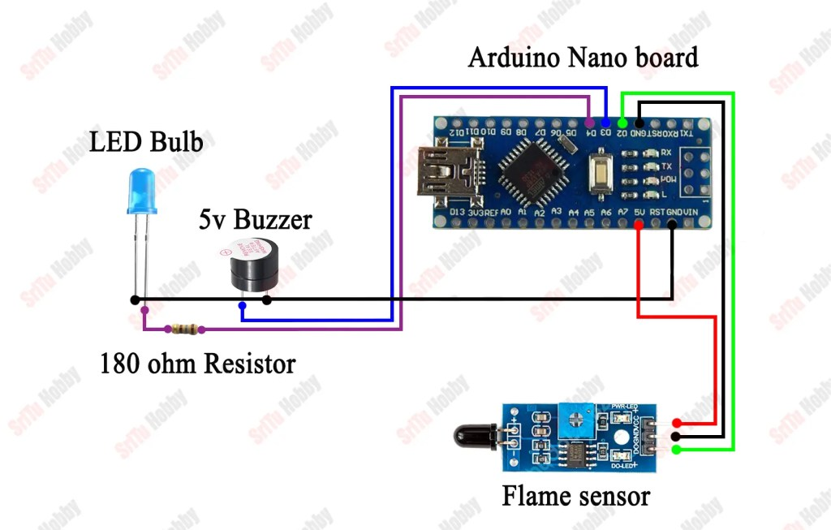

CODE
/*Flame sensor with Arduino Nano.
created by the SriTu Hobby team.
Home Page New
*/

#define Sensor A0
#define Buzzer 4
#define RedLED 2
#define GreenLED 3

void setup() {
Serial.begin(9600);
pinMode(Sensor, INPUT);
pinMode(RedLED, OUTPUT);
pinMode(GreenLED, OUTPUT);
pinMode(Buzzer, OUTPUT);
}

void loop() {
bool value = digitalRead(Sensor);
// Serial.println(value);

if (value == 0) {
digitalWrite(GreenLED, LOW);
digitalWrite(RedLED, HIGH);
digitalWrite(Buzzer, HIGH);
delay(200);
digitalWrite(Buzzer, LOW);
delay(200);
Serial.println("FIRE DETECTED - ALERT!!!!!!");
} else {
digitalWrite(RedLED, LOW);
digitalWrite(GreenLED, HIGH);
digitalWrite(Buzzer, LOW);
Serial.println("NO FLAME DETECTED - EVERYTHING IS NORMAL");
}
}

Applications

- Residential buildings
- Commercial establishments
- Industrial facilities
- Laboratories
- Server rooms
- Vehicles (e.g., cars, boats)

Conclusion
The fire alarm system project successfully demonstrates the implementation of a simple yet effective fire detection and alerting mechanism using readily available components and Arduino Nano microcontroller. With its ability to detect potential fire hazards and provide timely alerts, the system enhances safety and minimizes the risk of fire-related incidents in various environments. Further enhancements and customization can be explored to adapt the system for specific applications and requirements.

RESULT
The Fire Detector Alarm system using Arduino Nano was successfully implemented and tested. When a flame or ignition source was introduced near the flame sensor module, the sensor detected the infrared radiation and sent a signal to the Arduino Nano. The system responded by activating the buzzer and turning on the red LED, indicating a fire alert.
When no flame was present, the green LED remained ON, indicating normal conditions. The system effectively demonstrated quick detection and alerting of potential fire hazards, proving that the circuit and code function correctly.

FUTURE STEPS / FUTURE SCOPE
The project can be improved further with additional features:
- Integration with GSM module – The system can send SMS alerts to users during fire detection.
- Wireless monitoring – Adding Wi-Fi modules like ESP8266 Wi-Fi Module for remote monitoring through mobile or web applications.
- Automatic fire suppression – Integrating a water sprinkler system to automatically control fire.
- Multiple sensors – Adding smoke or temperature sensors to increase detection accuracy.
- IoT based system – Connecting the system to cloud platforms such as Arduino IoT Cloud for real-time monitoring and data logging.

REFERENCES
- Arduino IDE – Official documentation and programming environment.
- Arduino Official Website – https://www.arduino.cc
- Flame Sensor Module Datasheet and Arduino Tutorials from electronics learning websites.
- SriTu Hobby YouTube tutorials and Arduino project guides.
- Basic Electronics and Arduino project reference books and online learning materials.

